Step 1 :-
We need to run Web API service using Postman.
URL :- https://openfeed.5paisa.com/Feeds/api/UserActivity/LoginCheck
Request :-
{
"head": {
"appName": "<<Vendor AppName>>",
"appVer": "1.0",
"key": "<<Vendor key>>",
"osName": "Web",
"requestCode": "5PLoginCheck"
},
"body": {
"userId" : "<<Vendor Encrypted UserID>>",
"password": "<<Vendor Encrypted Password>>"
}
}

Success Response :-
{
"body": {
"Message": "Success",
"Status": 0
},
"head": {
"responseCode": "5PLoginCheck",
"status": 0,
"statusDescription": "Success"
}
}

Note:-
In Response if we get Status 0 and Message "Success", then Form Authentication Token will be generated and we will get Token in“.ASPXAUTH”in Cookies section in Response body but to get this Postman Interceptor should be enabled and for that please install Postman Interceptor.
Failure Response :-
{
"body": {
"Message": "No Records Found",
"Status": 1
},
"head": {
"responseCode": "Request Code will be displayed",
"status": 0,
"statusDescription": "Success"
}
}
Failure Response :-
{
"body": {
"Message": "Invalid Input Parameters",
"Status": 3
},
"head": {
"responseCode": "5PLoginCheck",
"status": 0,
"statusDescription": "Success"
}
}

Note:-
In Response if we get Status 1 and Message "No Records Found", then Form Authentication Token will not be generated and we will not get Token in“.ASPXAUTH”in Cookies section in Response body.

Step 2 :-
Install web socket Tester which is a chrome plugin. Please look at image below for reference.
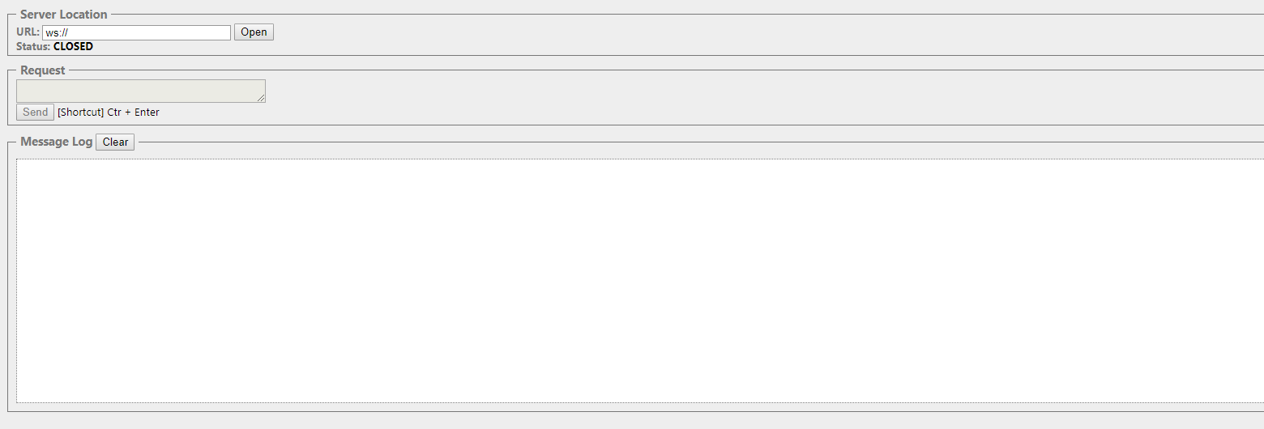
In URL please enter :-
wss://websocket.5paisa.com/TTWebSocket/api/chat?Value1=<<Pass ClientCode>>|<<Pass RegistrationID>>
Value1 is basically a pipe separated text which contains LoginId and RegistrationID which we entered while running API.

Check Status before clicking Open Button. It will show as Status: CLOSED

After I click on Open Button, Status: OPENED will be displayed which means we are able to connect to web socket successfully.

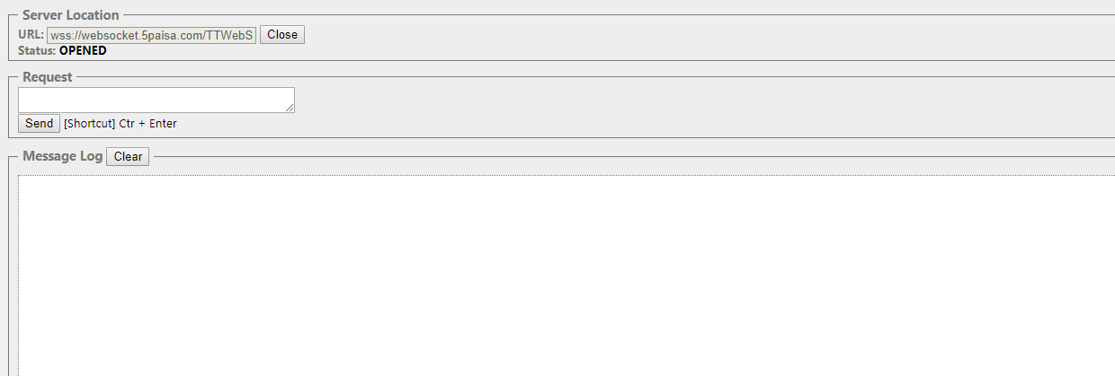

When you run Web API Service and in Response we get Status 1 and Message "No Records Found", we will not get form authentication token. If we enter URL in web socket tester tool and click on Open, we will not be able to open web socket connection.

Please go though image below.

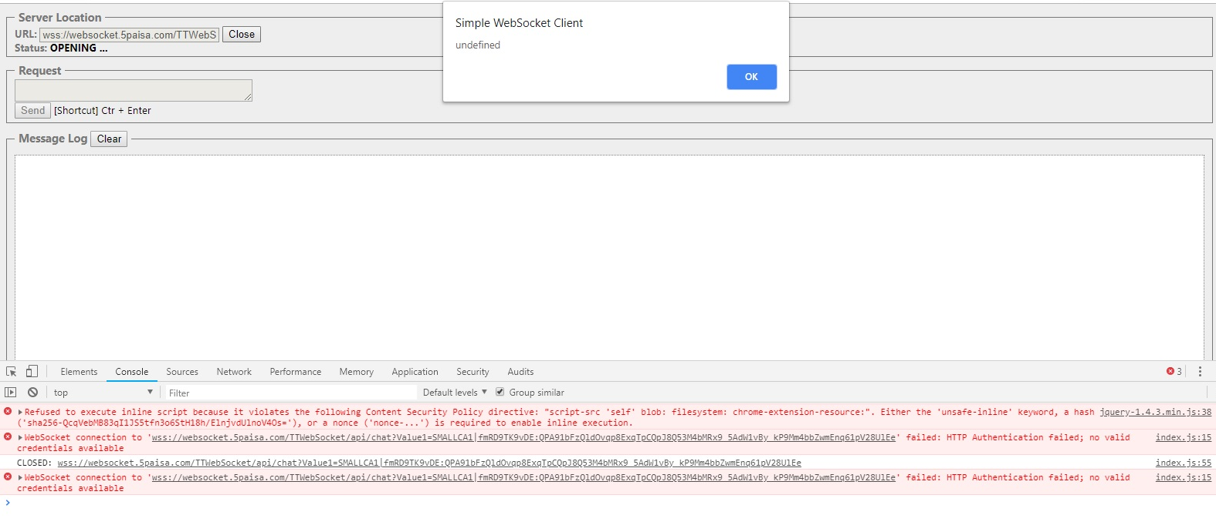
Step 3 :-
In Request please enter :-

{
"Method":"MarketFeedV3",
"Operation":"Subscribe",
"ClientCode":"<<Vendor Encrypted UserID>>",
"MarketFeedData":[
{
"Exch":"N",
"ExchType":"C",
"ScripCode":15083
}
]
}

And click on Send Button. We are basically Subscribing N,C,15083 for a particular Client Code.
We will now get live feeds. Please go through image below.

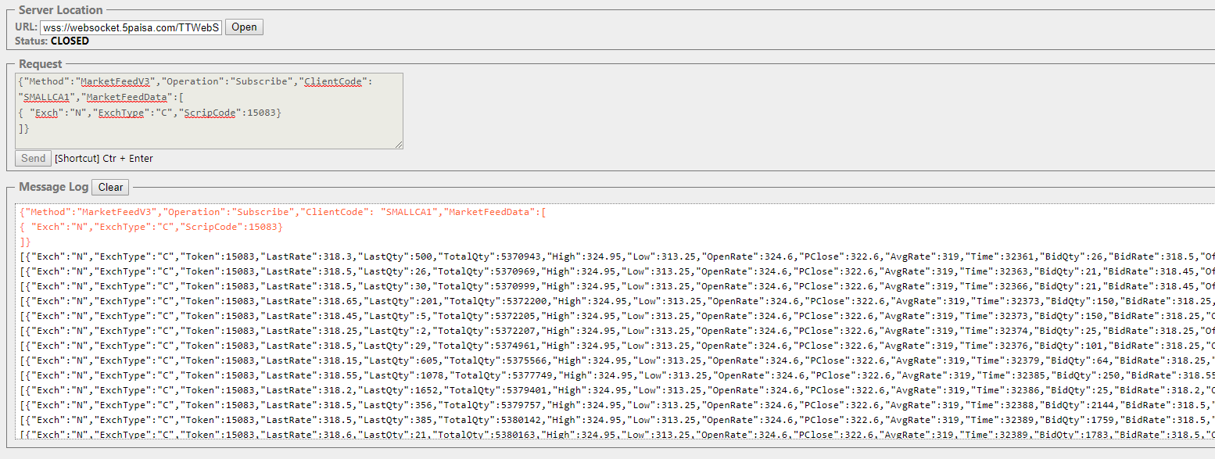

Similarly if we want to Subscribe multiple scrips we need to put in following Request :-

{
"Method":"MarketFeedV3",
"Operation":"Subscribe",
"ClientCode":"<<Vendor Encrypted UserID>>",
"MarketFeedData":[
{
"Exch":"N",
"ExchType":"C",
"ScripCode":15083
},
{
"Exch":"B",
"ExchType":"C",
"ScripCode":999901
},
{
"Exch":"N",
"ExchType":"C",
"ScripCode":22
}
]
}

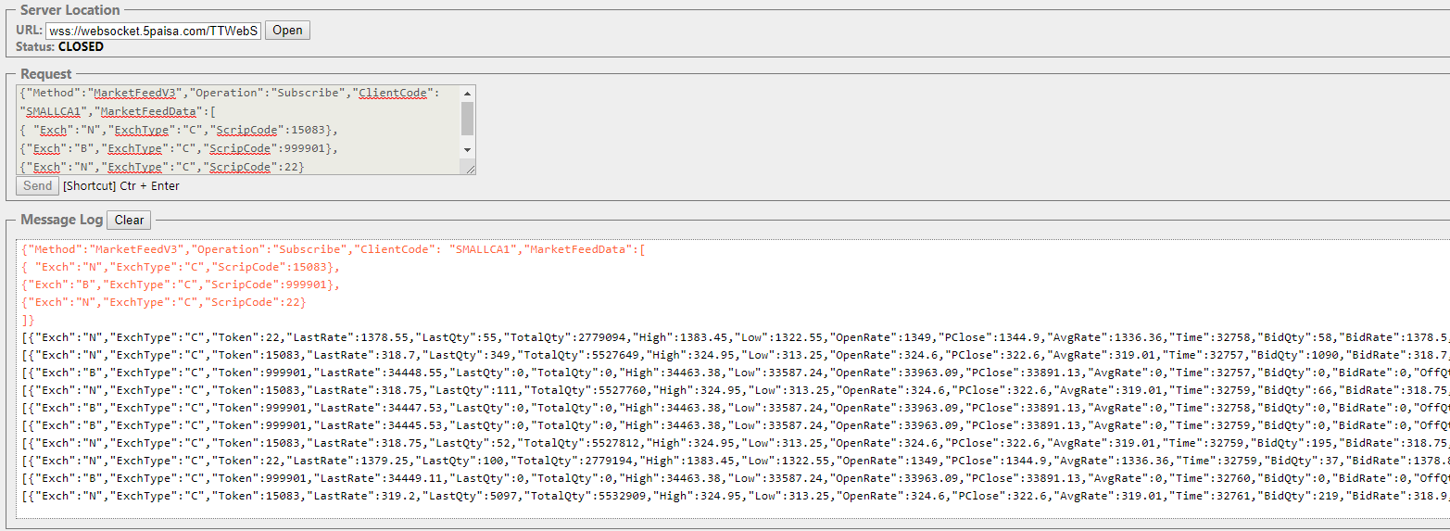

If we click on Close then we will stop receiving live feeds which means that user has Signed out.

If user wants to receive feeds again, user has to sign in again and Subscribe to Scrips again that is we need to follow process all over again.

At one time you can get feeds using LoginId and RegistrationID. If you use same LoginId and RegistrationID again to get feeds, it will allow you to login and get feeds but earlier session for that LoginId and RegistrationID will be disconnected.

If user wishes to Unsubscribe a particular scrip we need to pass following in Request:-

{
"Method":"MarketFeedV3",
"Operation":"Unsubscribe",
"ClientCode":"<<Vendor Encrypted UserID>>",
"MarketFeedData":[
{
"Exch":"N",
"ExchType":"C",
"ScripCode":15083
}
]
}

In this case we will continue receiving feeds of N,C,999901 and N,C,22 and we will stop receiving live feeds of N,C,15083 as we have unsubscribed this scrip.

To get Indices data we need to pass ScripCode(IndiceID). Please go through list given below as we will need Exch, ExchType and ScripCode(IndiceID):-

ScripCode(IndiceID) | Exch | ExchType | IndexName
0 | N | C | Nifty 50
2 | N | C | Nifty 500
3 | N | C | Nifty 100
4 | N | C | Nifty IT
5 | N | C | BANK NIFTY
6 | N | C | NIFTY Midcap 100
7 | N | C | Nifty Next 50
8 | B | C | SENSEX
19 | N | C | India VIX
20 | N | C | NiftyMidcap50
21 | N | C | Nifty Realty
22 | N | C | Nifty Infra
23 | N | C | Nifty Energy
24 | N | C | Nifty FMCG
25 | N | C | Nifty MNC
26 | N | C | Nifty Pharma
27 | N | C | Nifty PSE
28 | N | C | Nifty PSU Bank
29 | N | C | Nifty Service
32 | N | C | HangSeng
33 | B | C | BSE AUTO
34 | B | C | BSE BANKEX
35 | B | C | BSE CONSUMER DURABLE
36 | B | C | BSE CAPITAL GOODS
37 | B | C | BSE HELATHCARE
38 | B | C | BSE IT
39 | B | C | BSE 100
40 | B | C | BSE 200
41 | B | C | BSE 500
42 | B | C | BSE FMCG
43 | B | C | BSE IPO
44 | B | C | BSE PSU
45 | B | C | BSE CARBON
46 | B | C | BSE CPSE
47 | B | C | DOL100
48 | B | C | DOL200
49 | B | C | DOL30
50 | B | C | GREENX
51 | B | C | BSE INFRA
52 | B | C | BSE METAL
72 | N | C | Nifty SML100 Free
73 | N | C | Nifty Mid Liq 15
74 | N | C | Nifty Pvt Bank
75 | N | C | Nifty Quality 30
76 | N | C | Nifty GS 8 13Yr
77 | N | C | Nifty GS 10Yr
78 | N | C | Nifty GS 10Yr Cln
79 | N | C | Nifty GS 4 8Yr
80 | N | C | Nifty GS 11 15Yr
81 | N | C | Nifty GS 15YrPlus
82 | N | C | Nifty GS Compsite
98 | B | C | S&P BSE SENSEX Next 50
99 | B | C | S&P BSE Bharat 22

Note:- 1st and 2nd Step will be the same. For 3rd Step refer things mentioned below.

In Request please enter :-

{"Method":"Indices","Operation":"Subscribe","ClientCode":"<<Pass ClientCode>>","MarketFeedData":[
{ "Exch": "N","ExchType": "C","ScripCode": 0}
]}

And click on Send Button. We are basically Subscribing N,C,0 for a particular Client Code.
We will now get live feeds. Please go through image below.

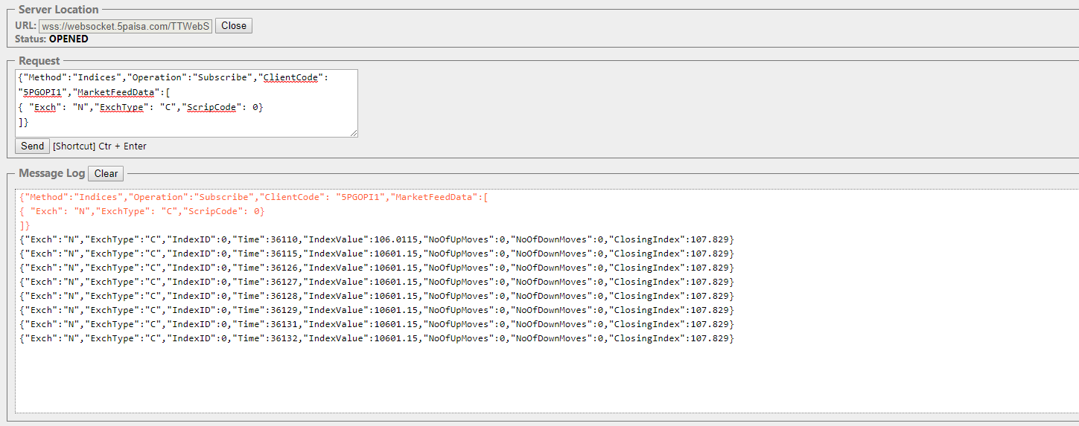

Similarly if we want to Subscribe multiple scrips we need to put in following Request :-

{"Method":"Indices","Operation":"Subscribe","ClientCode":"<<Pass ClientCode>>","MarketFeedData":[
{ "Exch": "N","ExchType": "C","ScripCode": 0},
{ "Exch": "B","ExchType": "C","ScripCode": 8}
]}

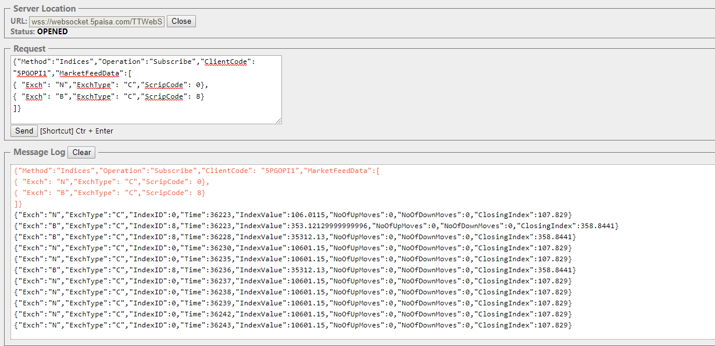

If we click on Close then we will stop receiving live feeds which means that user has Signed out.

If user wants to receive feeds again, user has to sign in again and Subscribe to Scrips again that is we need to follow process all over again.

At one time you can get feeds using LoginId and RegistrationID. If you use same LoginId and RegistrationID again to get feeds, it will allow you to login and get feeds but earlier session for that LoginId and RegistrationID will be disconnected.

If user wishes to Unsubscribe a particular scrip we need to pass following in Request:-

{"Method":"Indices","Operation":"Unsubscribe","ClientCode":"<<Pass ClientCode>>","MarketFeedData":[
{ "Exch":"N","ExchType":"C","ScripCode":0}
]}

In this case we will continue receiving feeds of N,C,8 and we will stop receiving live feeds of N,C,0 as we have unsubscribed this scrip.

Market Depth

Note:- 1st and 2nd Step will be the same. For 3rd Step refer things mentioned below.

In Request please enter :-

{"Method":"MarketDepthService","Operation":"Subscribe", "ClientCode":"<<Pass ClientCode>>","MarketFeedData":[
{ "Exch":"N","ExchType":"D","ScripCode":50210}
]}

And click on Send Button. We are basically Subscribing N,D,50210 for a particular Client Code.
We will now get live feeds. Please go through image below.

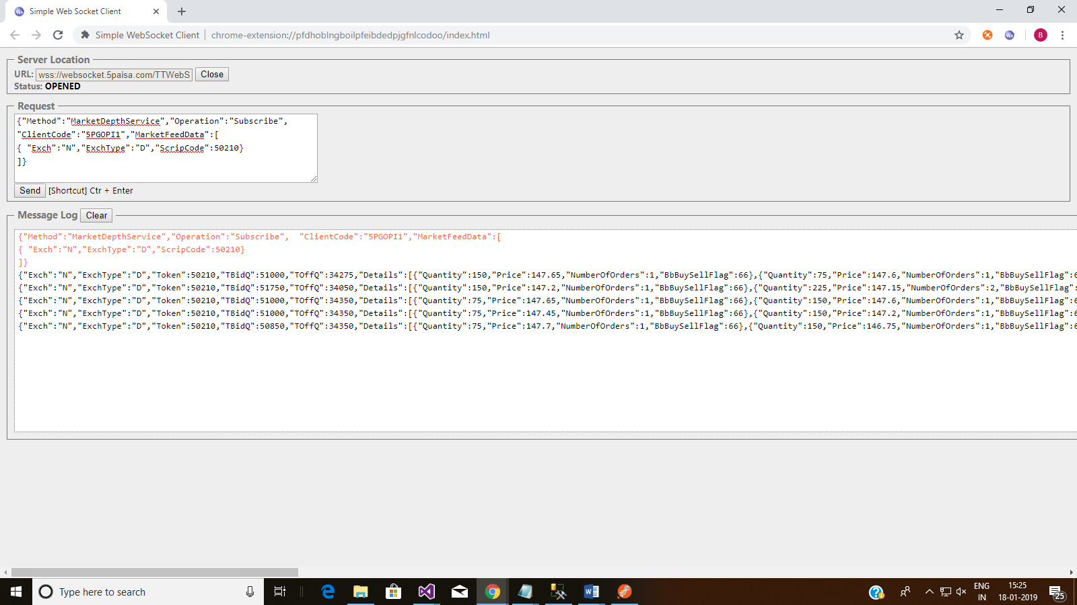

Similarly if we want to Subscribe multiple scrips we need to put in following Request :-

{"Method":"MarketDepthService","Operation":"Subscribe", "ClientCode":"<<Pass ClientCode>>","MarketFeedData":[
{ "Exch":"N","ExchType":"D","ScripCode":50210},
{ "Exch":"N","ExchType":"D","ScripCode":52699},
{ "Exch":"N","ExchType":"D","ScripCode":98562},
{ "Exch":"N","ExchType":"D","ScripCode":98563},
{ "Exch":"N","ExchType":"D","ScripCode":98564}
]}

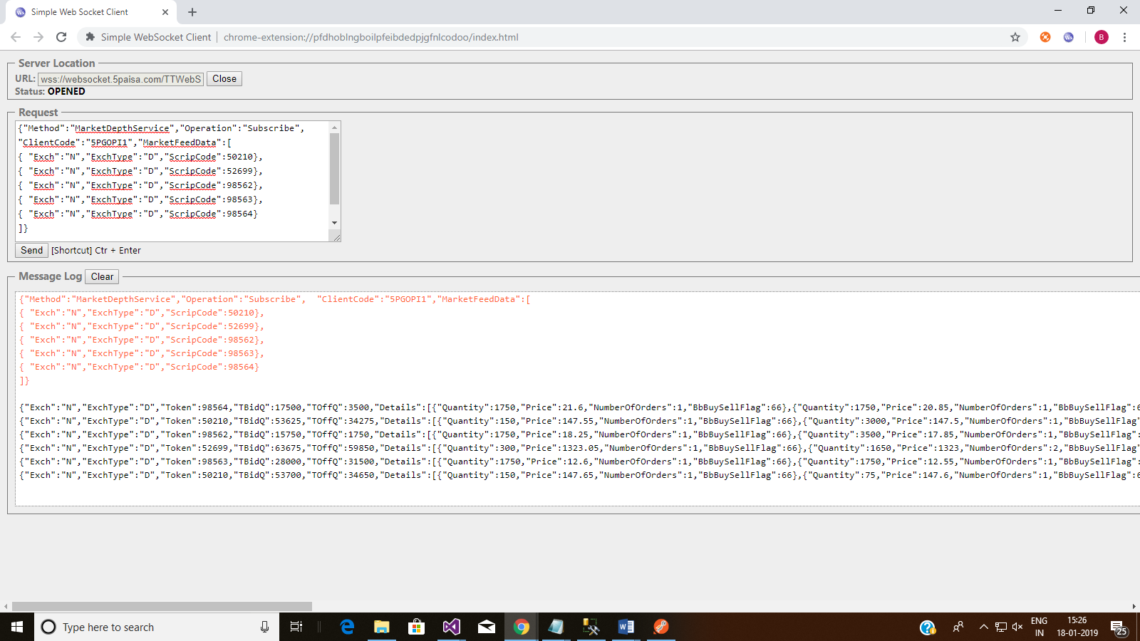

If we click on Close then we will stop receiving live feeds which means that user has Signed out.

If user wants to receive feeds again, user has to sign in again and Subscribe to Scrips again that is we need to follow process all over again.

At one time you can get feeds using LoginId and RegistrationID. If you use same LoginId and RegistrationID again to get feeds, it will allow you to login and get feeds but earlier session for that LoginId and RegistrationID will be disconnected.

If user wishes to Unsubscribe a particular scrip we need to pass following in Request:-

{"Method":"MarketDepthService","Operation":"Unsubscribe",
"ClientCode":"<<Pass ClientCode>>","MarketFeedData":[
{ "Exch":"N","ExchType":"D","ScripCode":50210}
]}

In this case we will continue receiving feeds of N,D,52699 | N,D,98562 | N,D,98563 | N,D,98564 and we will stop receiving live feeds of N,D,50210 as we have unsubscribed this scrip.

Open Interest

Note:- 1st and 2nd Step will be the same. For 3rd Step refer things mentioned below.

In Request please enter :-

{"Method":"GetScripInfoForFuture","Operation":"Subscribe",
"ClientCode": "<<Pass ClientCode>>”,"MarketFeedData":[
{ "Exch":"N","ExchType":"D","ScripCode":46429}
]}

And click on Send Button. We are basically Subscribing N,D,46429 for a particular Client Code.
We will now get live feeds. Please go through image below.

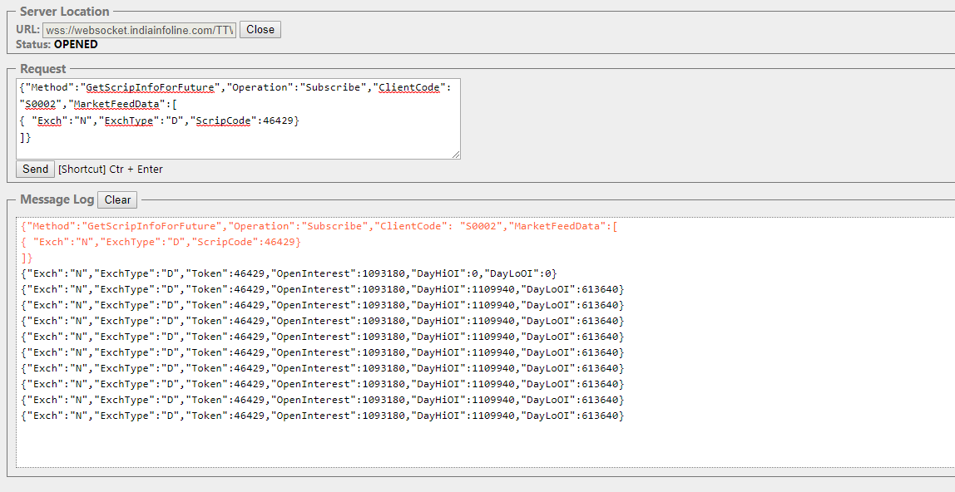

Similarly if we want to Subscribe multiple scrips we need to put in following Request :-

{"Method":"GetScripInfoForFuture","Operation":"Subscribe", "ClientCode":"<<Pass ClientCode>>","MarketFeedData":[
{ "Exch":"N","ExchType":"D","ScripCode":52581},
{ "Exch":"N","ExchType":"D","ScripCode":52443}
]}

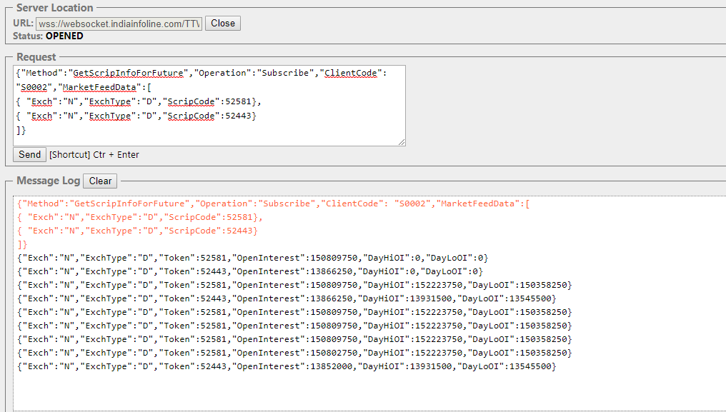

If we click on Close then we will stop receiving live feeds which means that user has Signed out.

If user wants to receive feeds again, user has to sign in again and Subscribe to Scrips again that is we need to follow process all over again.

At one time you can get feeds using LoginId and RegistrationID. If you use same LoginId and RegistrationID again to get feeds, it will allow you to login and get feeds but earlier session for that LoginId and RegistrationID will be disconnected.

If user wishes to Unsubscribe a particular scrip we need to pass following in Request:-

{"Method":"GetScripInfoForFuture","Operation":"Unsubscribe",
"ClientCode":"<<Pass ClientCode>>","MarketFeedData":[
{ "Exch":"N","ExchType":"D","ScripCode":52581}
]}

In this case we will continue receiving feeds of N,D,52443 and we will stop receiving live feeds of N,D,52581 as we have unsubscribed this scrip.

